Client Consent Form

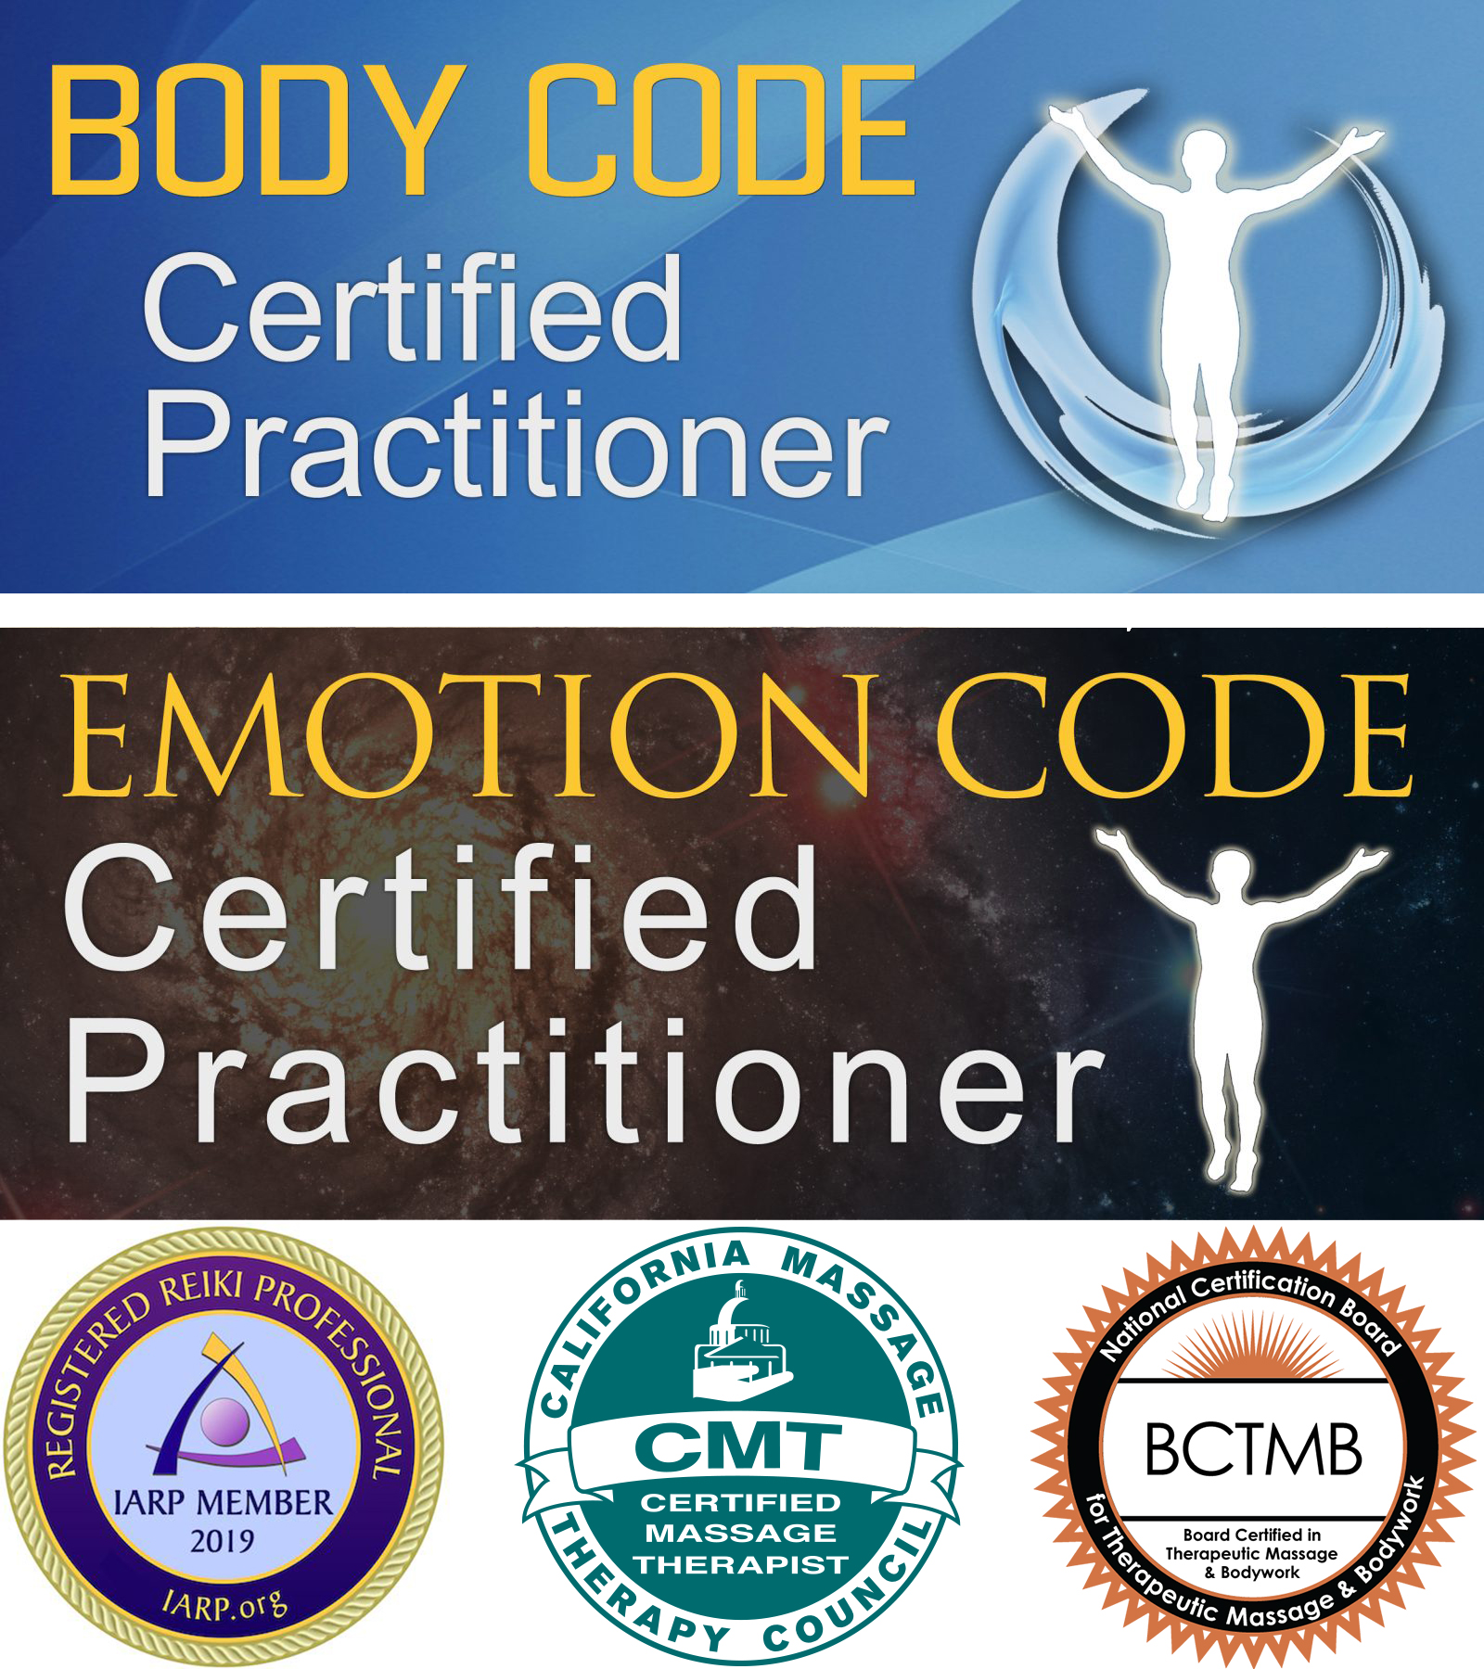

EDUCATION AND TRAINING:

After graduating from the Soma Institute of Chicago om 2006, I was licensed in the State of Illinois and Nationally by the NCBTMB in massage therapy, with a specialization in clinical massage. The massage portion of my business is “Fixit Massage” as I get to the heart of muscle issues causing pain and limitations to daily life. Since 20006 I started adding on energy therapies to compliment the hands-on work. Most recently I became Emotion Code and Body Code certified by Discover Healing, which ties together the clinical with the energetic for powerful, lasting results.

BASIC DESCRIPTION OF EMOTION CODE/BODY CODE SERVICES AND TECHNIQUES:

The Emotion Code & Body Code techniques are simple ways to rid the body of emotional baggage helping you feel freer, happier and healthier! Because the body is made of pure energy, the negative energies of trapped emotions can exert a damaging force on the body, which worsens over time. Trapped Emotions cause pain, self-sabotage, emotional problems and all kinds of malfunction and disease.

The Body Code is an advanced healing technique bringing balance in six different ways.

* **Energy:**  To correct this area of imbalance, I identify and remove damaging emotional and mental energies that can become trapped in the body during stressful emotional events.
* **Circuitry:**  Involves balancing the energy systems of the body including the chakras, the acupuncture meridians, the connection of the spiritual and physical body, and the energy circuits of organs and glands.
* **Toxicity:**  Identifies and addresses toxic agents that may or may not be diagnosed in medical tests. This can include removing energies and offering suggestions for detoxification.
* **Pathogens:** Destructive and often elusive infections can be identified. In addition to clearing energies, I can suggest other remedies to rid the body of these pathogens.
* **Structural:**  Imbalances in the bones, organs, connective tissue, muscles and nerves can be identified and balanced non-invasively to gently restore stability to the physical body.
* **Nutritional:**  This can involve identifying nutrient deficiencies as well as imbalances such as dehydration, magnetic field deficiency or a need for certain healing foods.

DISCLOSURE OF HEALTH INFORMATION:

Please download the “**Client Intake Form**” which asks for full disclosure of any health information that might impact your treatments (such as pregnancy) or physical limitations (like breathing or extreme pain issues). Gerry Lampert cannot be held responsible for any information not disclosed to her regarding current and past medical or emotional conditions.

CONFIDENTIALITY OF RECORDS AND CLIENTS RIGHTS:

At any time, you have the right to discontinue services, change consent, or leave. You also have the right to ask any question about your session. Your client information and records are treated in a confidential manner. Your experiences during these sessions are confidential subject to the usual exceptions governed by state or federal laws and regulations.

Confidentiality is subject to the following exceptions:

1. You may instruct me to release information to other health care practitioners in writing.
2. I may release information if subpoenaed or otherwise am obligated or reasonably allowed to do so (including circumstances where there is clear and imminent danger to yourself or another person.)
3. Your confidential personal file is kept in a secure location and is retained for 4 years after you suspend services after which time all information will be destroyed in a proper manner.
4. Your confidentiality is always subject to the usual exclusions dictated by state and federal laws and regulations.

RELEASE OF LIABILITY

Emotion Code/Body Code is a gentle, complementary energy based approach to health and healing that can assist your body in its natural ability to heal. This may be accomplished through the use of some contact to the back (governing meridian) with a magnet. You may decline any physical contact, change your consent to any physical contact at any time, or leave. Should you choose not to have any physical contact, you have the option to give consent for Gerry Lampert to act as “proxy” for you so that you may still enjoy the benefits of a session.

Emotion Code/Body Code services through Gerry Lampert @ Treat The Whole You is a complementary therapy not intended to replace any currently prescribed medical treatments as ordered by your physicians nor any other medical care you have or may be advised to seek. Services with Gerry Lampert @ Treat The Whole You is not medical advice or medical treatment and is not meant to replace medical advice of your doctor. You will be encouraged to consult a licensed medical practitioner for any physical or mental complaints you may have.

While Emotion Code/Body Code is a gentle, complementary energy based approach, there may be risks. Most people process the energy released very easily. However, occasionally, there may be some symptoms that come along with processing that you need to be aware of. Usually this is something minor, such as emotional irritability or a little fatigue, but it could end up being something more uncomfortable like headache or nausea. It all depends on what we released, what's going on with your body at the time, your stress level at the time and many other external factors. You can make the processing period easier by getting extra sleep the night before, drinking a lot of pure water, and avoiding stressful situations. Your name and your business asks that you contact her immediately if any processing work is too uncomfortable so that she may help you. All energies released are intended to release gently and peacefully.

All client information and records are treated in a confidential manner. Your experiences during these sessions are confidential subject to the usual exceptions governed by state or federal laws and regulations.

Except in the case of gross negligence or malpractice, you or your representative agrees to fully release and hold harmless Gerry Lampert @ Treat The Whole You and against any and all claims or liability of whatsoever kind or nature arising out of or in connection with my session.

My questions have been answered to my satisfaction regarding Gerry Lampert @ Treat The Whole You background.

If I am a phone-in client, I understand that when paying for services, I fully consent to the services offered by Gerry Lampert @ Treat The Whole You:

I agree to allow Gerry Lampert @ Treat The Whole You to send me information via e-mail. I understand that my e-mail address will be kept confidential and will not be given to a 3rd party.

By signing below, I fully consent to use the services offered by Gerry Lampert @ Treat The Whole You

**Microsoft Office Signature Line...Microsoft Office Signature Line...**

If the patient is a minor, parent or guardian signature is required

**Microsoft Office Signature Line...Microsoft Office Signature Line...**

**Disclaimer**

All information provided in On Butterfly Wings LLC is provided without any warranties or guarantees.  We make no warranties of any kind, either express or implied.  All information in the Butterfly Files is to be used at your own risk and based on your own judgment.  For our full Disclaimer, please go to [www.BuildMyHealingBusiness.com](http://www.BuildMyHealingBusiness.com).